Title of Your Contribution
Author Aª, Author B^{b}, …
ª Department, Institution/Company, Town, State/Country, Email-Address
^{b} Department, Institution/Company, Town, State/Country

1 page of text

Up to 2 pages of figures/illustrations

1 page for references

Summary
Your abstract will be used in the review process to evaluate your contribution to the conference. The total length of the abstract is ４ pages – the first page contains three sections of text, the second and third page are for figures – figure captions can be used as a very effective tool to complement the information provided in the main text.
In the Summary section clearly state the novelty and originality in your work. The degree of novelty will be one of the major evaluation criteria in the review process. The Summary section should succinctly describe your major achievements and the overall conclusions of your work. You must not submit work that has already been published elsewhere, either at a conference on in a journal. Please do not change the font style and size and try to limit the Summary section to about 1000 characters (including spaces). Ensure it is self-contained and explanatory: this section constitutes the text that is going to appear in the abstract book that will be distributed at the conference.

Background and motivation
The Motivation section should be used to describe the background of your work and its relationship to previous work in the field. References should be given on the last page using common IEEE referencing styles. Make sure to also refer explicitly to the Figures you provide on the second and third page to illustrate basic structures, device designs, etc. (see Fig. 1).

Methodology and Results
Use this template to create your abstract, and convert to PDF format prior to submission. The Results section should convey the details of your approach and outcome of your work, including experimental methods, data, modeling, etc. It is mandatory to present only existing results – please do not refer to anticipated results. Illustrate your approach and your results by referring to the figures on the second page (see Fig. 2 and Fig. 3). The second and third page should contain figures only!

Figures (up to 2 pages – use captions effectively to complement information in the main text on the first page)
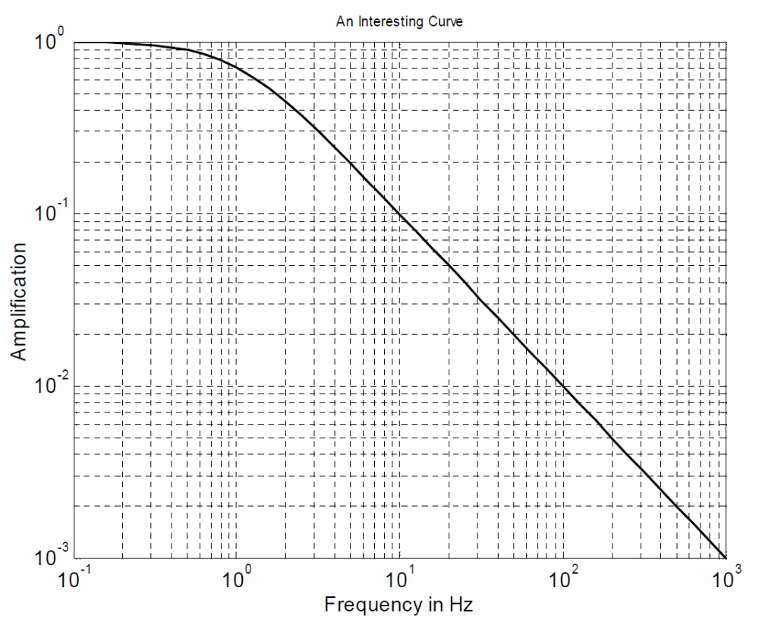
Fig. 3: You may include up to six figures on the second page. A minimum of two figures is recommended. All figures must fit on this page.
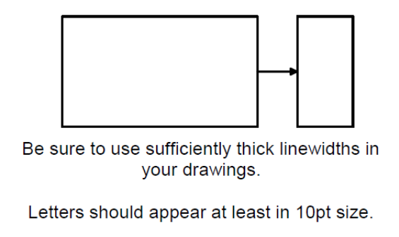
Fig. 1: Briefly describe figure contents. Try to make captions self-explanatory.
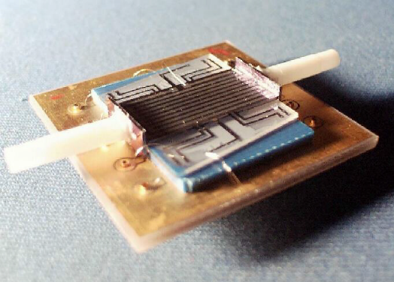
Fig. 2: When using photos, make sure the resolution is sufficient.

References (sample referencing style)

[1] Yawger, R., 2023. WiPDA Celebrates Tenth Anniversary [PSMA Corner]. IEEE Power Electronics Magazine, 10(3), pp.64-66.
[2] Armstrong, K.O., Das, S. and Cresko, J., 2016, November. Wide bandgap semiconductor opportunities in power electronics. In 2016 IEEE 4th Workshop on Wide Bandgap Power Devices and Applications (WiPDA) (pp. 259-264). IEEE.
[3] Funaki, T., Balda, J.C., Junghans, J., Kashyap, A.S., Mantooth, H.A., Barlow, F., Kimoto, T. and Hikihara, T., 2007. Power conversion with SiC devices at extremely high ambient temperatures. IEEE Transactions on Power electronics, 22(4), pp.1321-1329.
[4] …

